MODEL #: ERV0200003 SERIAL #: EC00002447-H JOB #: 60284
MOTOR: 20HP
PHASE: 3PH
POWER SUPPLY: 208/230V
MOTOR CURRENT: 57.5/55.2 AMPS
MAX PSI: 145
MIN PSI: 90
TEMP RANGE: 34-115F
CONTROL TYPE: STANDARD DRIVE
MAINTENANCE PARTS
AIR FILTER: FILTER007
OIL FILTER: FILTER070
SEPARATOR: FILTER009
OIL: OIL003 (1.6G)
SERVICE KIT: SKIT003
BELT: BELT016 (3)
Manual and warranty info visit www.emaxcompressor.com
Sales, parts, tech support (866)294-4153
OIL CHECK
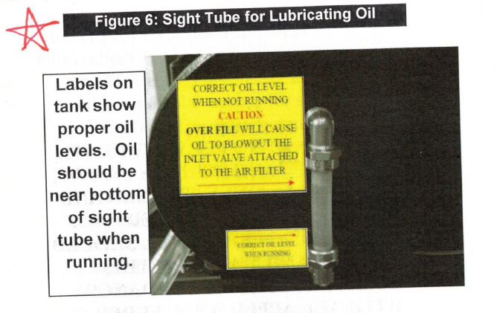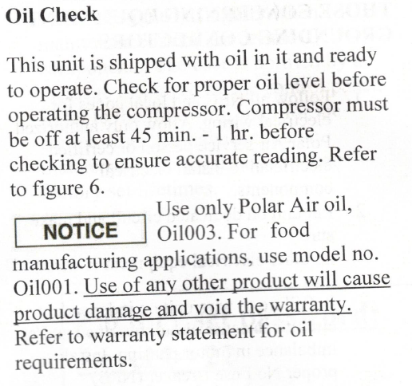
OIL CAPACITY 20HP – 1.5 GALLON. DO NOT OVERFILL. RESIDUAL OIL MAY BE IN COMPRESSOR. USE UPPER ARROW FILL LINE ON SIGHT GLASS.

